

<Process Title>

<Apex/Group/Operational> Layer

Document Version / Details: Ver. 2.0/ 14-Nov-2022

WORD DOCUMENT

1. Vaccum Command Syntax :-

VACUUM table_name [RETAIN num HOURS] [DRY RUN]

2. Version command-

select * from table_name Version as of 8.

Restore table_name to Version as of 8

3. Optimize command -

OPTIMIZE table_name [WHERE predicate]

[ZORDER BY (col_name1 [, ...] ) ]

4. Diff b/w All purpose and Job Cluster –

You run these workloads as a set of commands in a [notebook](https://docs.databricks.com/en/notebooks/index.html) or as an automated [job](https://docs.databricks.com/en/workflows/jobs/create-run-jobs.html). Databricks makes a distinction between all-purpose clusters and job clusters. You use all-purpose clusters to analyze data collaboratively using interactive notebooks. You use job clusters to run fast and robust automated jobs.

* You can create an all-purpose cluster using the UI, CLI, or REST API. You can manually terminate and restart an all-purpose cluster. Multiple users can share such clusters to do collaborative interactive analysis.
* The Databricks job scheduler creates a job cluster when you run a [job](https://docs.databricks.com/en/workflows/jobs/create-run-jobs.html) on a new job cluster and terminates the cluster when the job is complete. You cannot restart a job cluster.



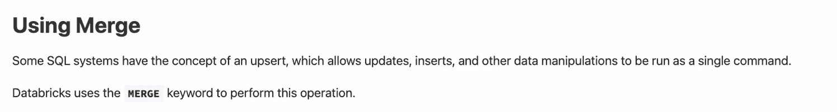

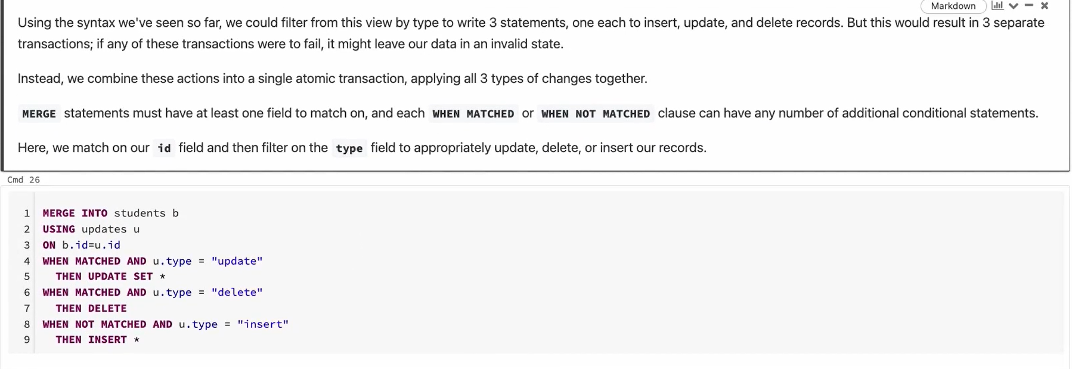

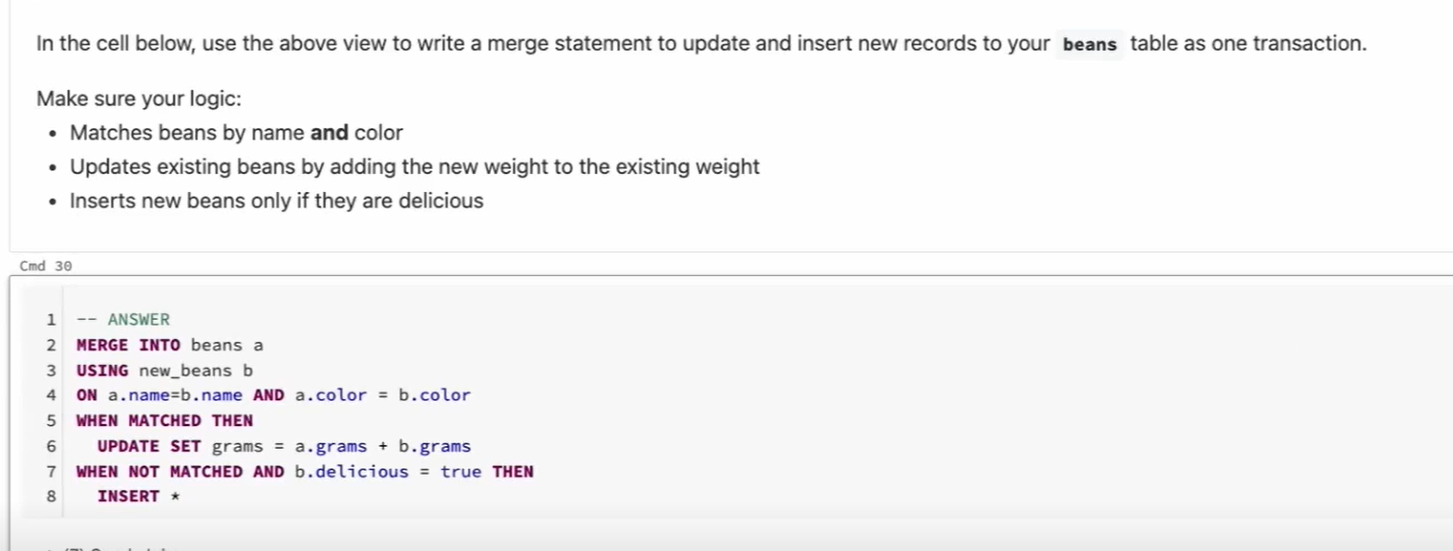



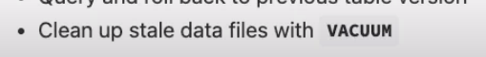

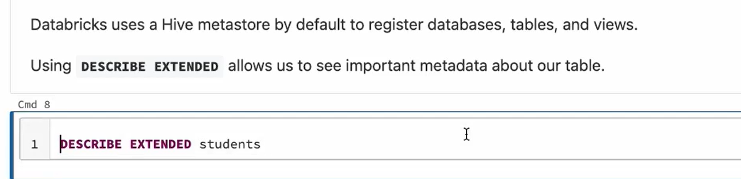

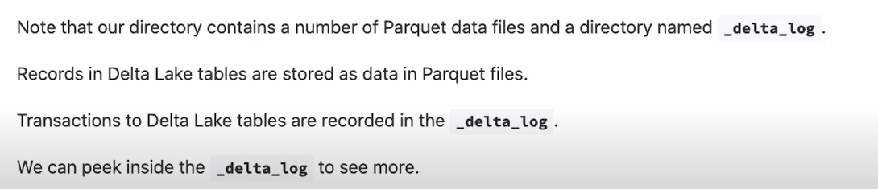





Working of Optimize, Vaccum, Zorder - <https://medium.com/@amarkrgupta96/unlocking-performance-optimize-vacuum-and-z-ordering-in-databricks-delta-tables-6ce20999f6f5>

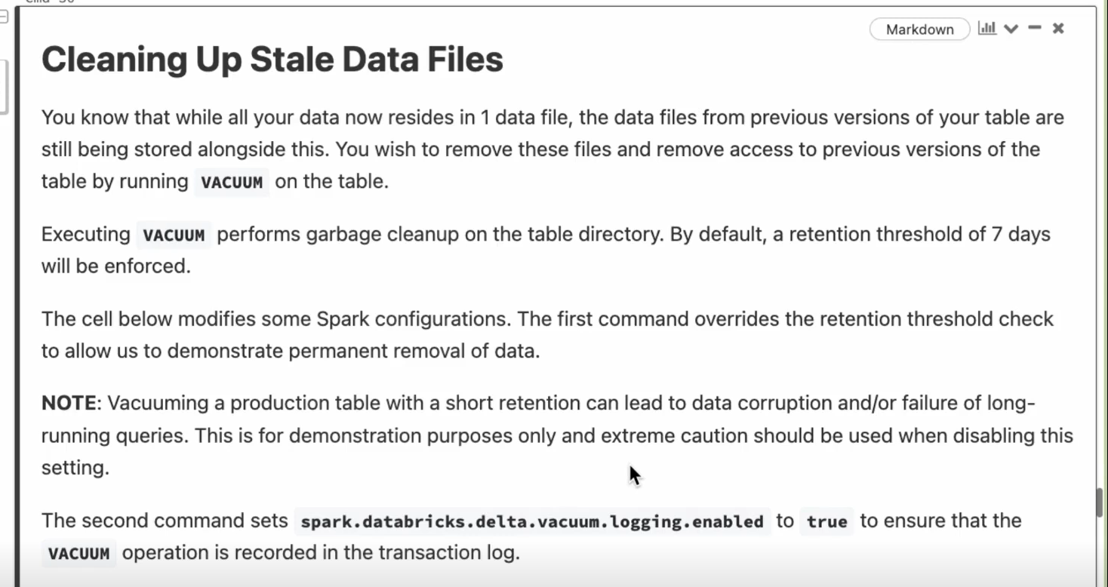

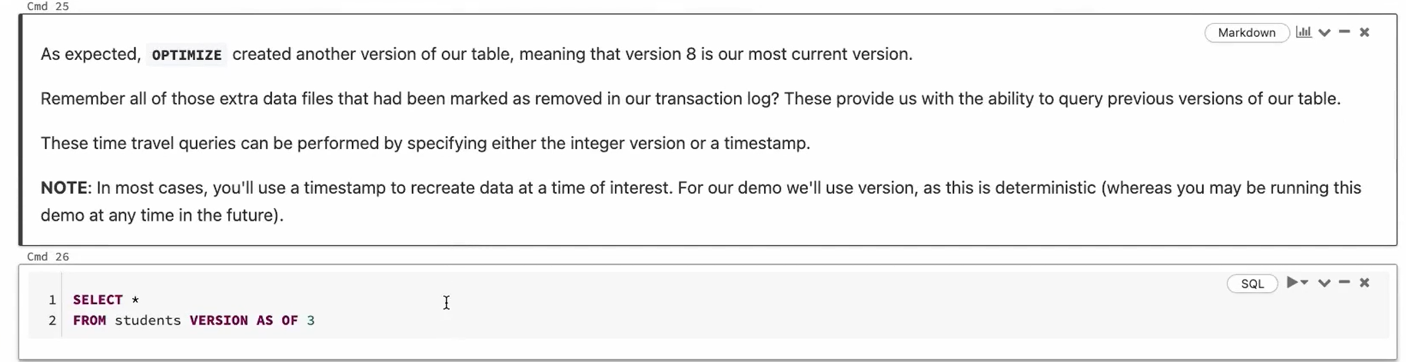

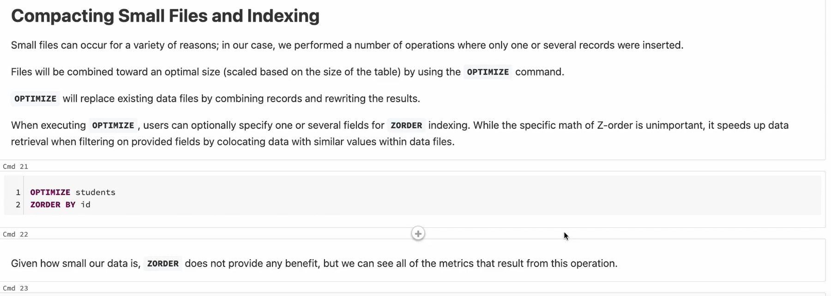

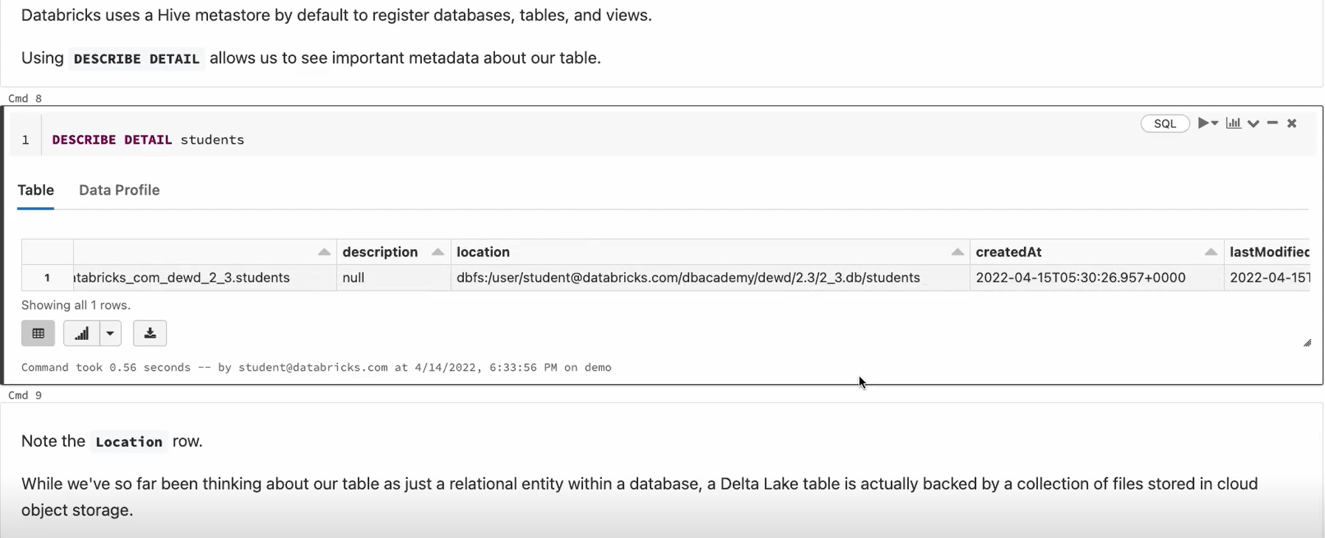

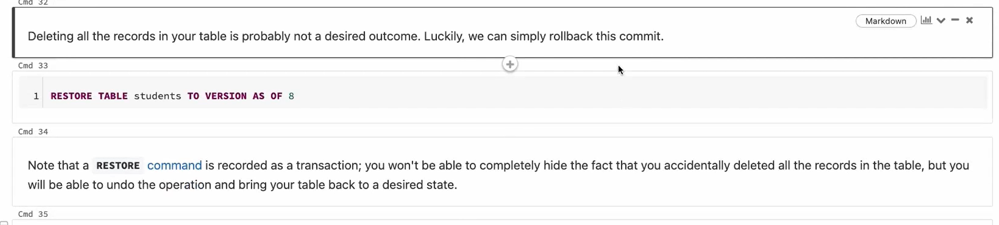

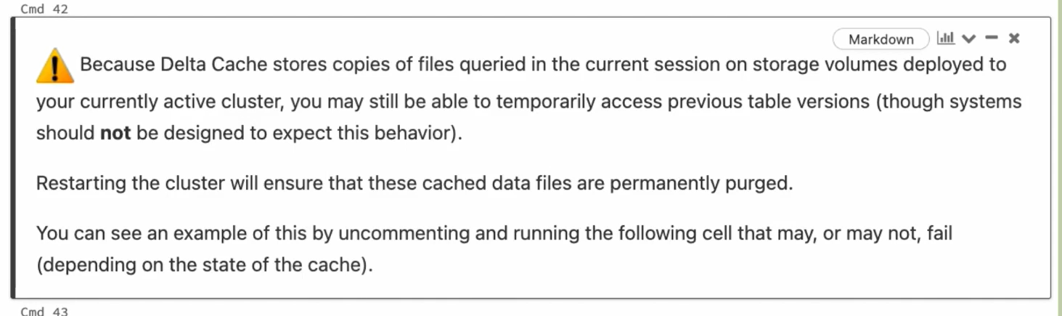



If the database location is other than the default location of db and if you create a table under that database , that table will still be considered a Managed table (Because the database and table both are present in the same location)

But even if the database location is default and we try to specify the LOCATION keyword for the table and give the location other than where the db location then it is considered as an External Table (Because the location of db and table are not the SAME)

Note – (If you specify a location keyword for table while creating means it is an external table)

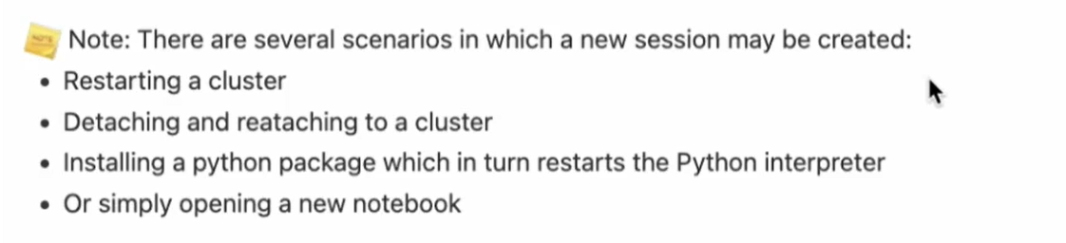

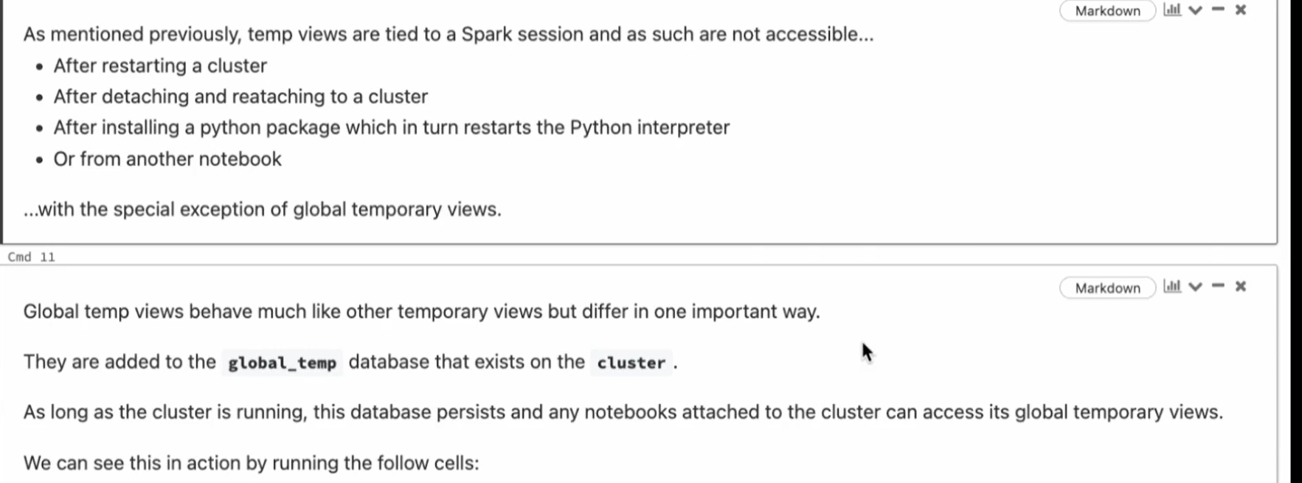

Table and Views -> Resides inside the db and still exists even when the cluster is restarted.

Temporary View -> Does not reside in any db and attached to Current Notebook/Spark Session

Global Temp View -> Resides inside the Global Temp db( Always a new Global Temp db is created when the new cluster is started). It can exist across many Spark Sessions/Notebooks until the current cluster is stopped.

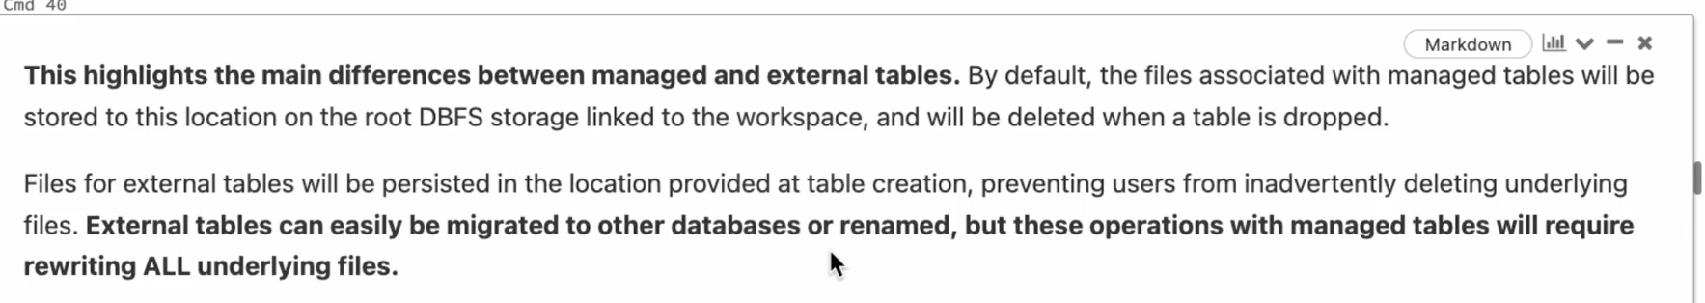

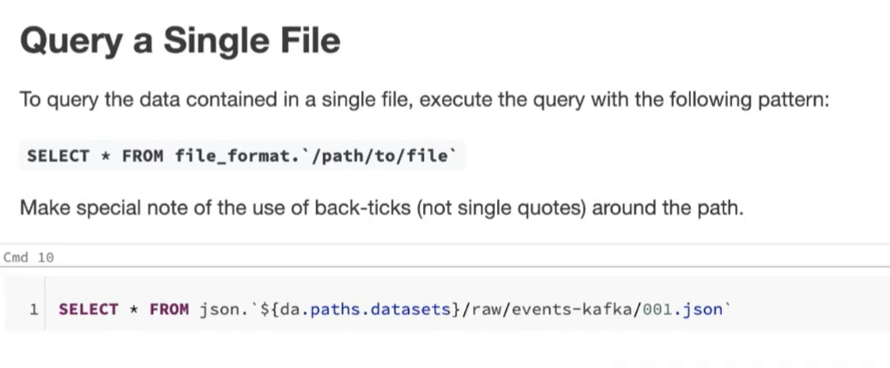

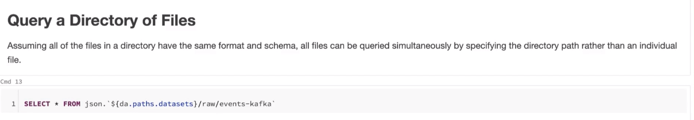

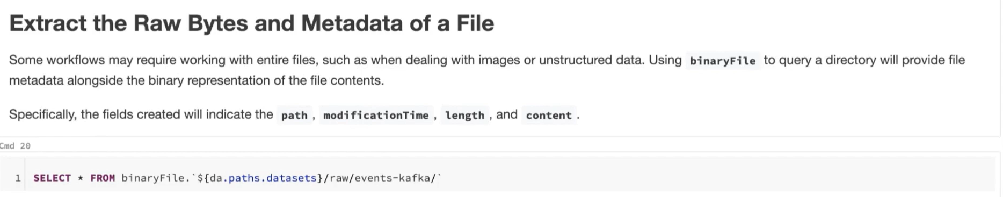

Csv is not a self-describing file format

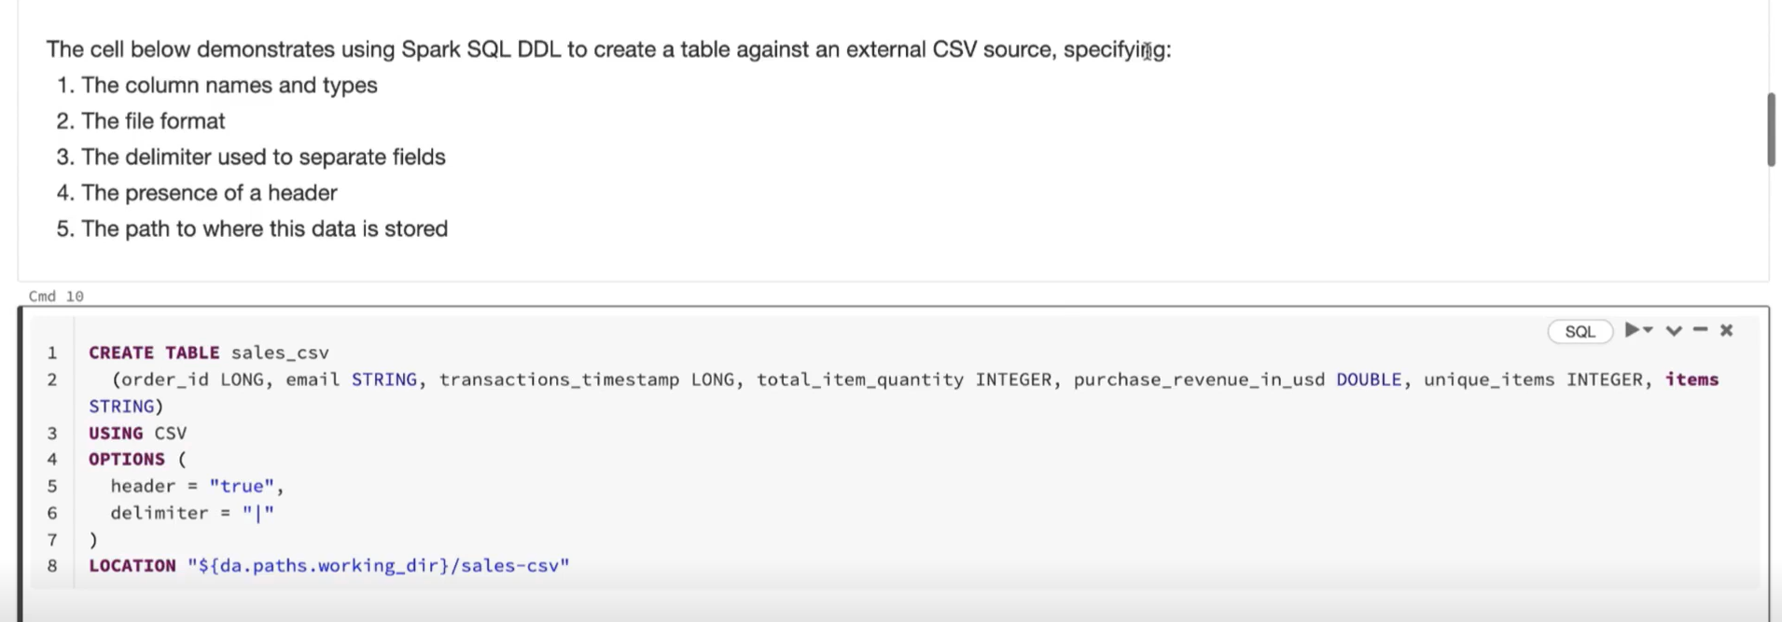

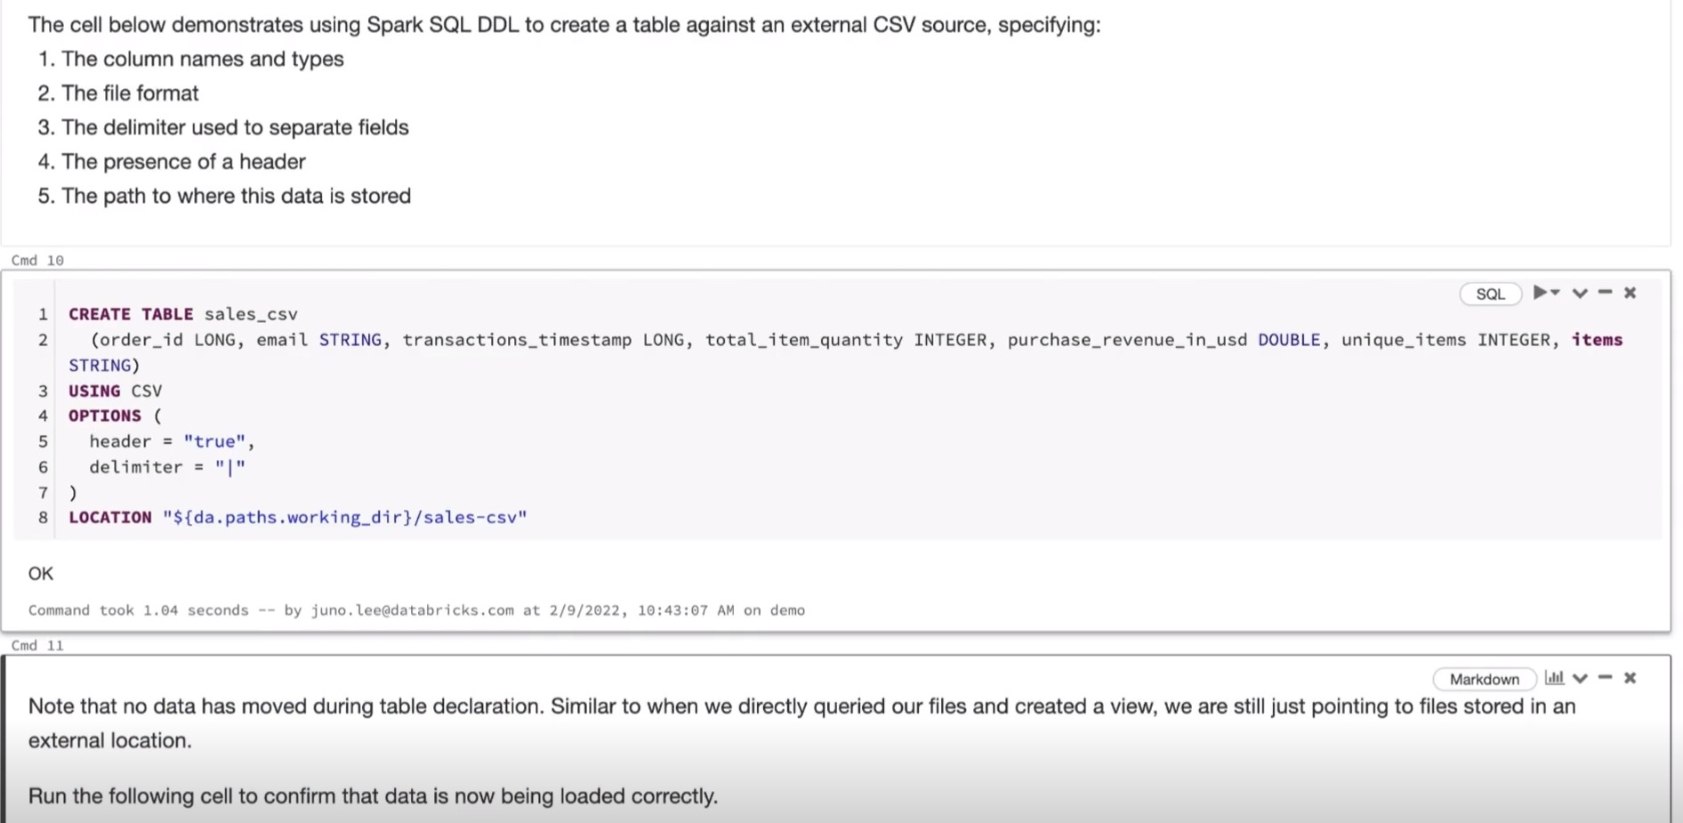

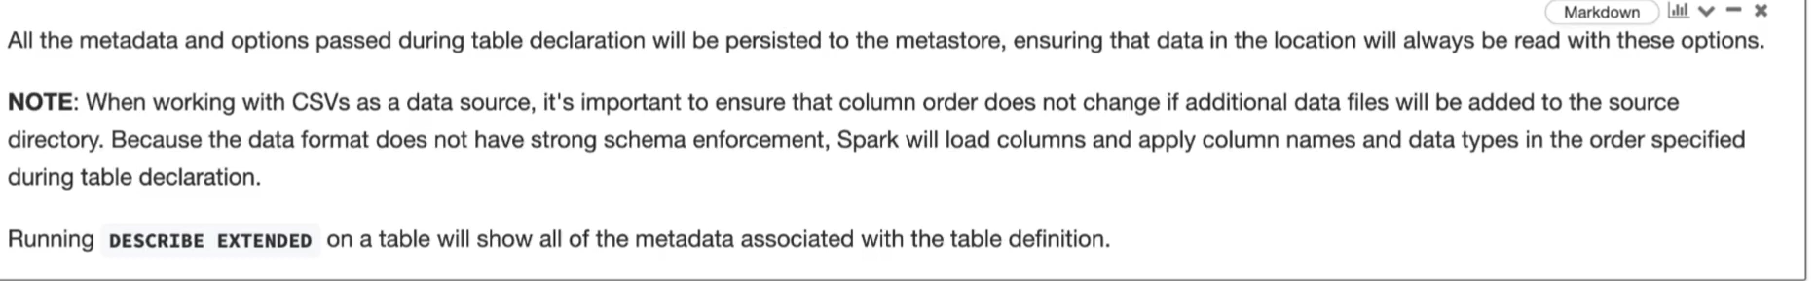

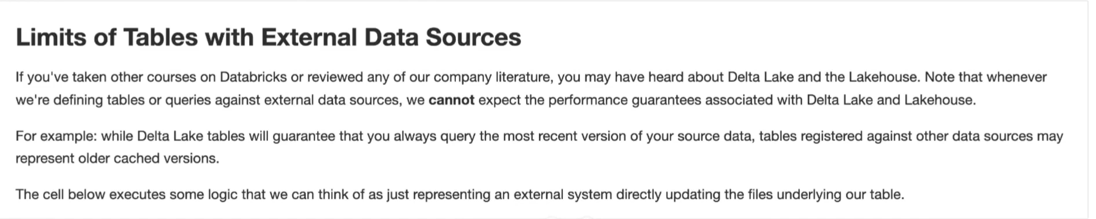

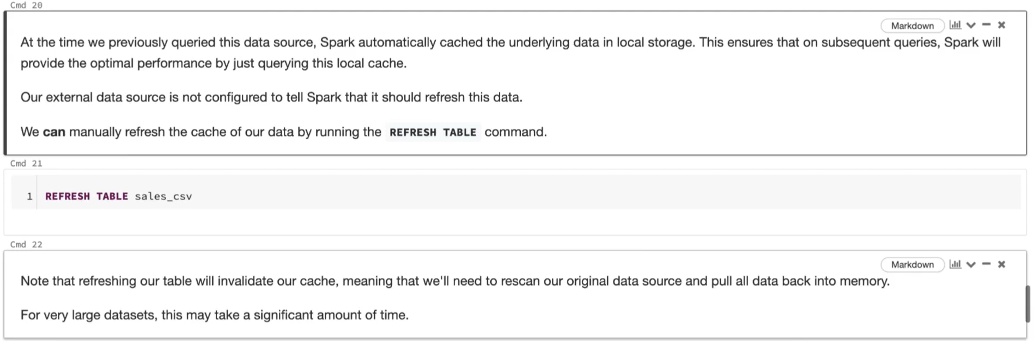

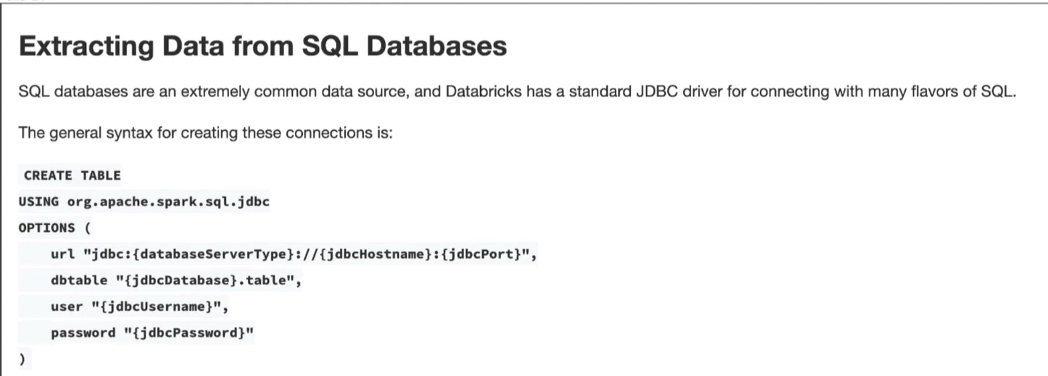

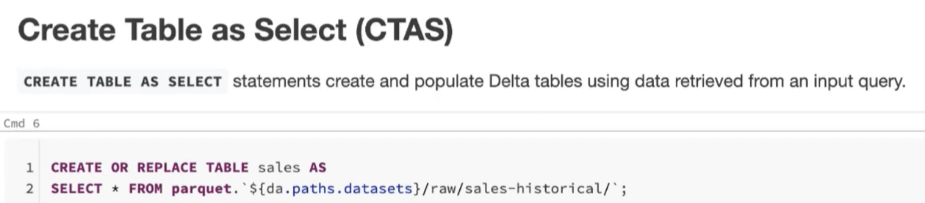

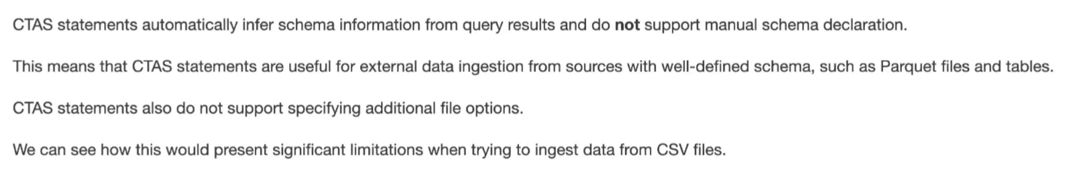

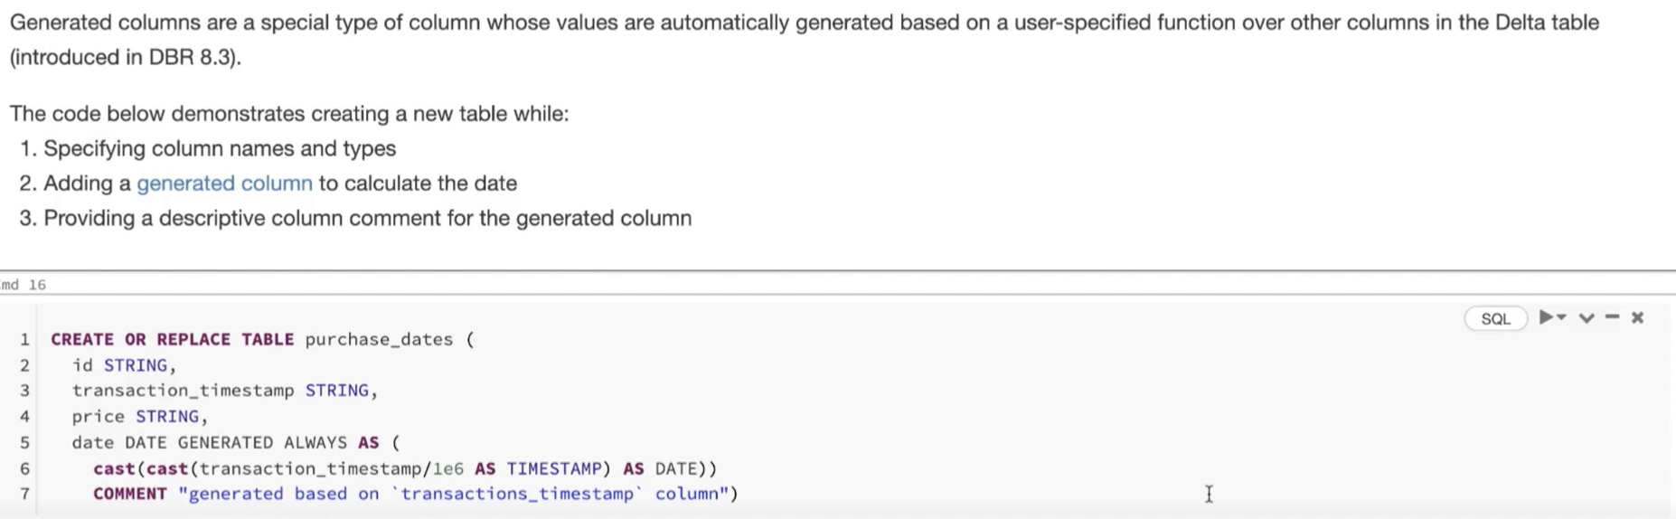

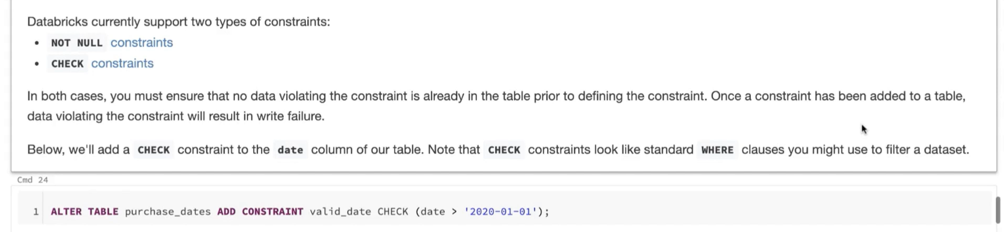

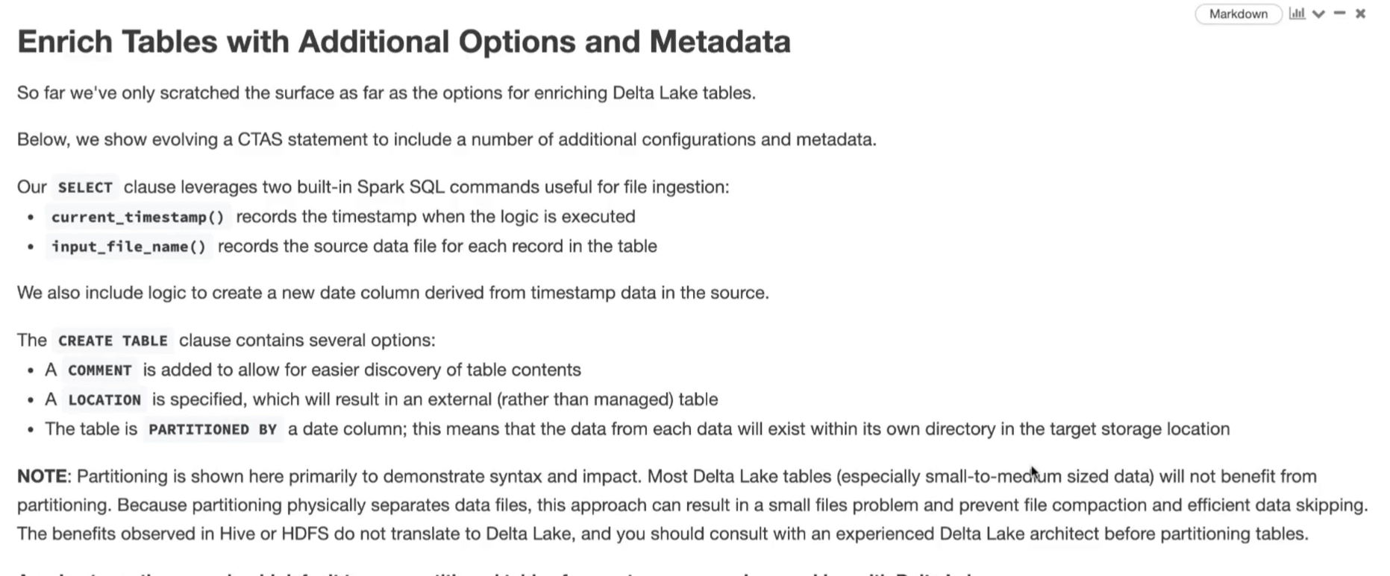

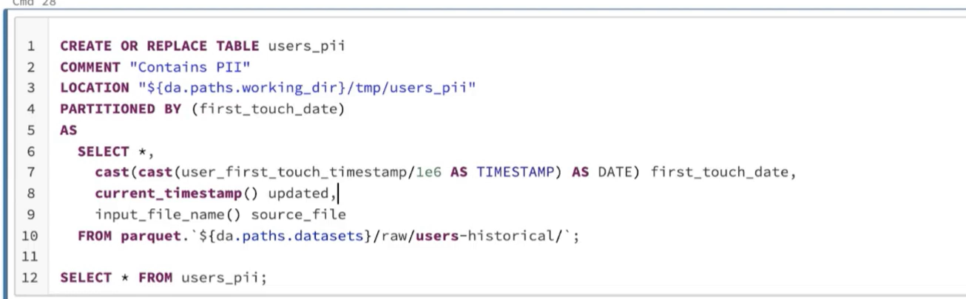

This is an external table since LOCATION keyword is specified for table (below comment) and not because it is specifying the location of where the source of the data (parquet.’path’) is present .

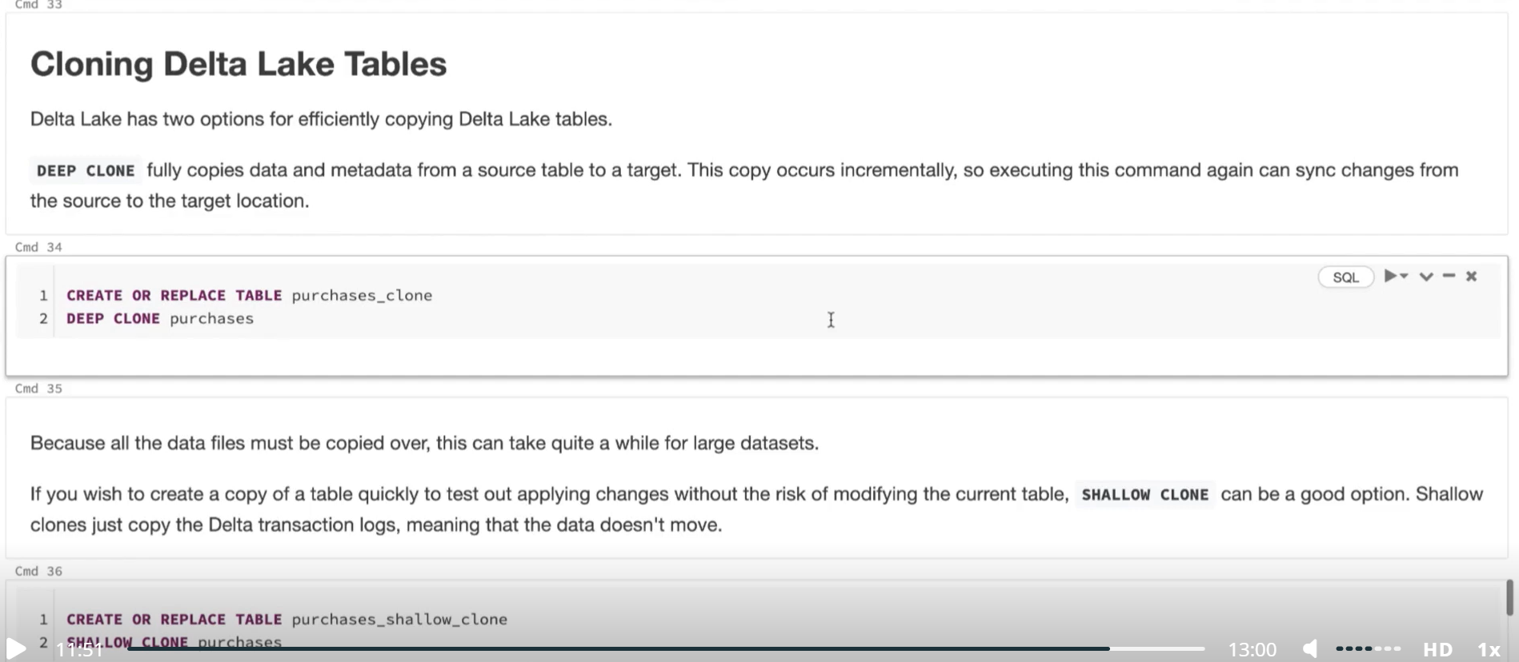

Writing to Delta Tables can be done in various ways such as –

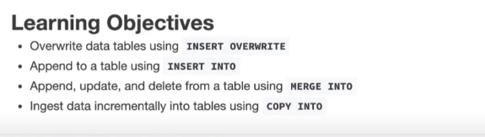

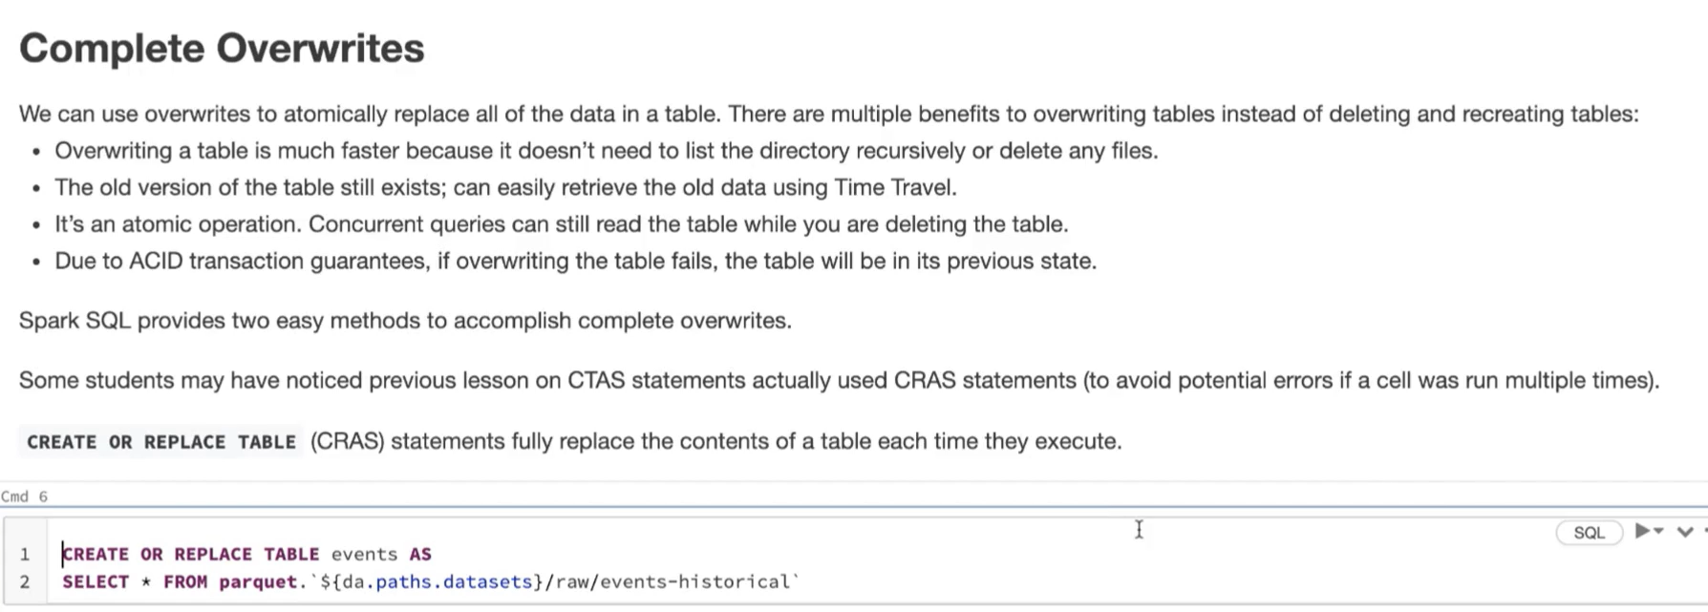

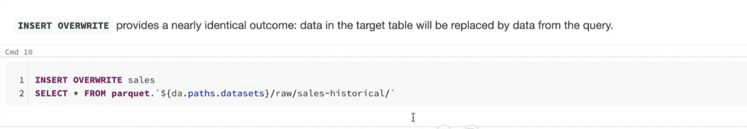

Overwite to Delta Table can be done by 2 ways – 1) CRAS statement 2) INSERT OVERWRITE

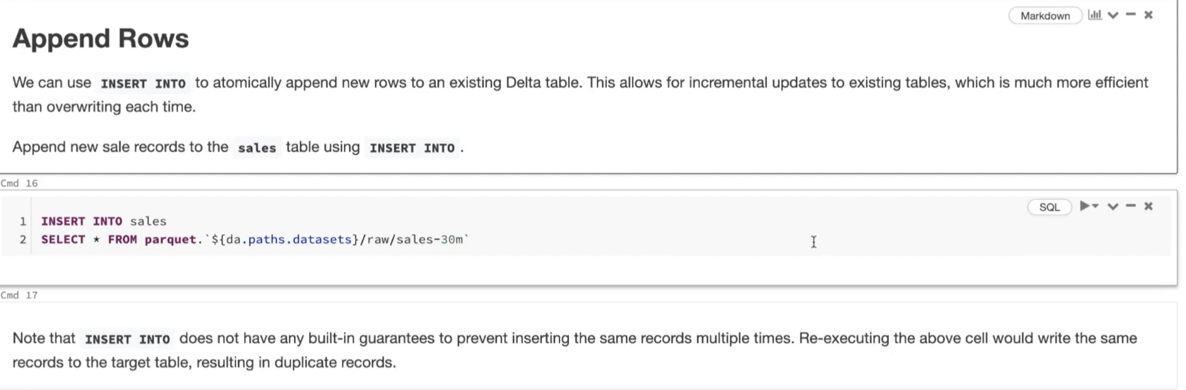

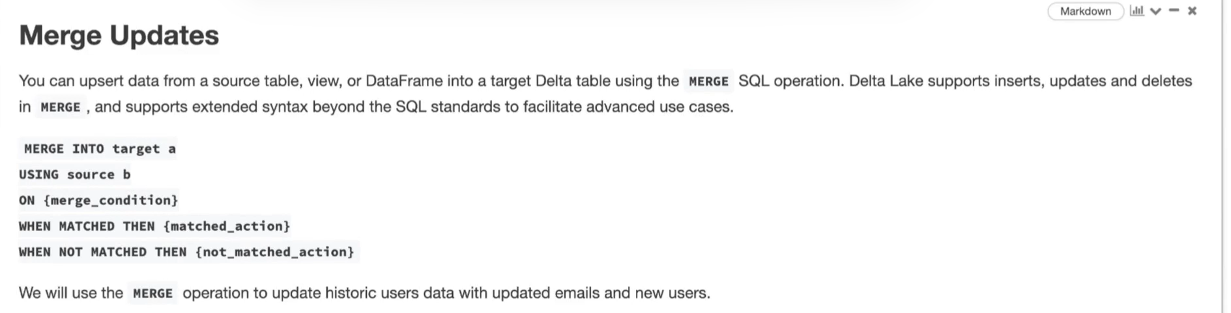

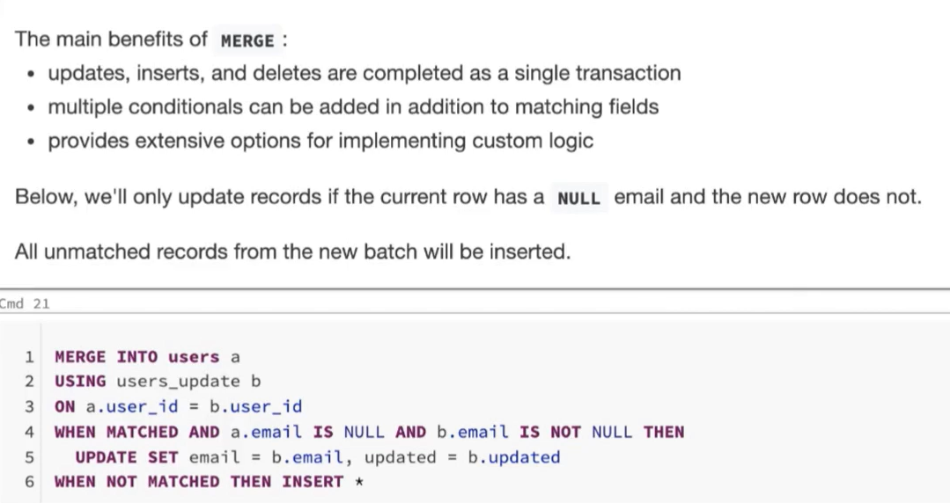

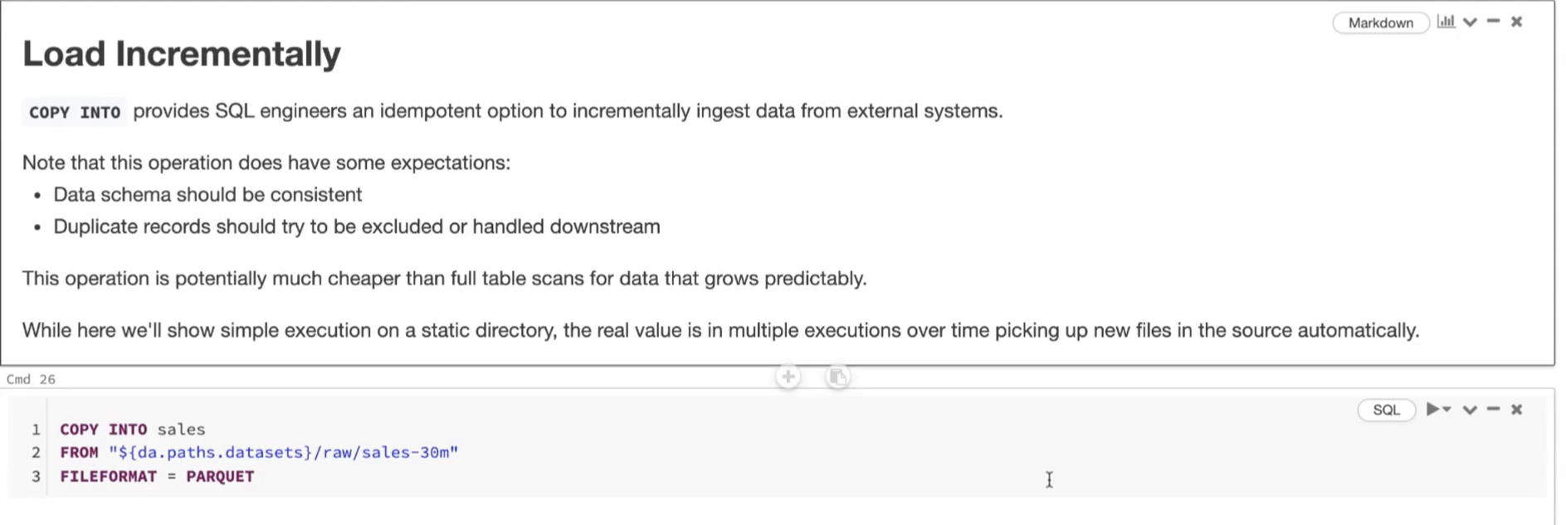

Diff b/w External Table and Managed Table

a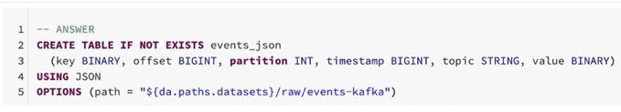

b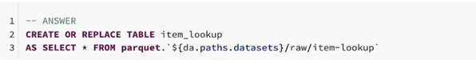

Whether Location/Path keyword is specified for the table or for the source where data is available it will be considered as a External Table because all the _delta_log files will be generated there in that place (Even though my .csv files reside in that path my _delta_log files will also be generated in the same path).   
  
But for b image (ctas statement) we are not using location/path keyword rather we are giving the path directly via SELECT statement so it is a MANAGED Table. Since Select will just retrieve the data from that location .

Note – CTAS statements always make Managed Table

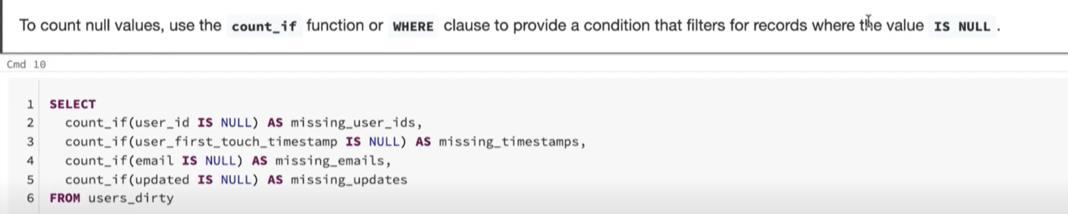

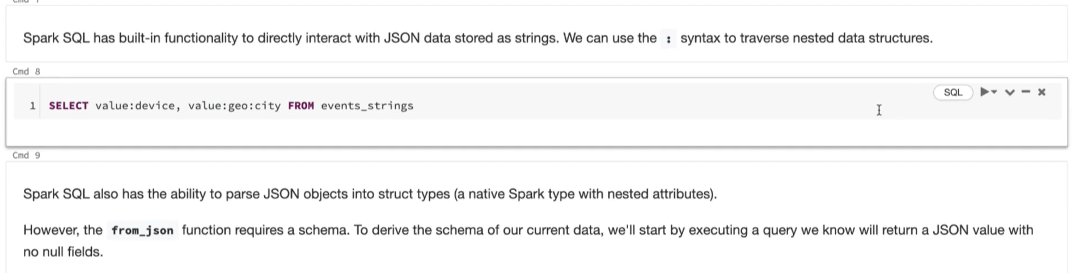

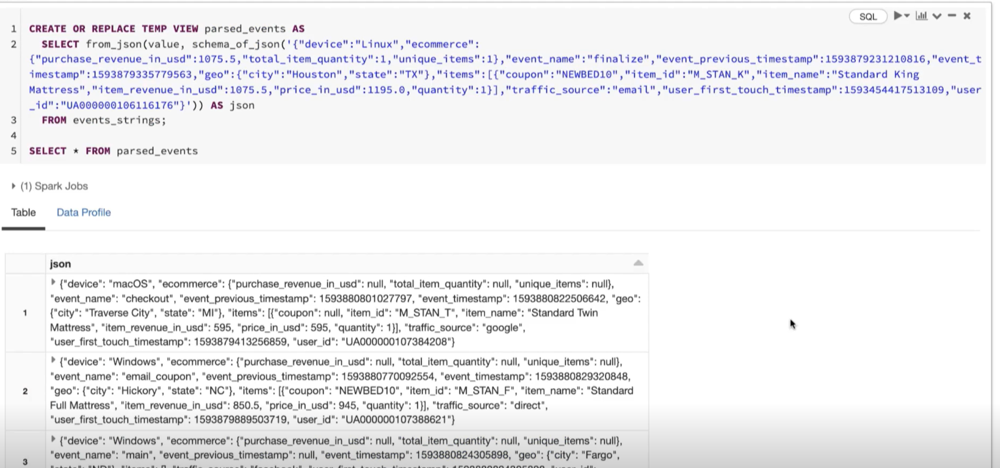

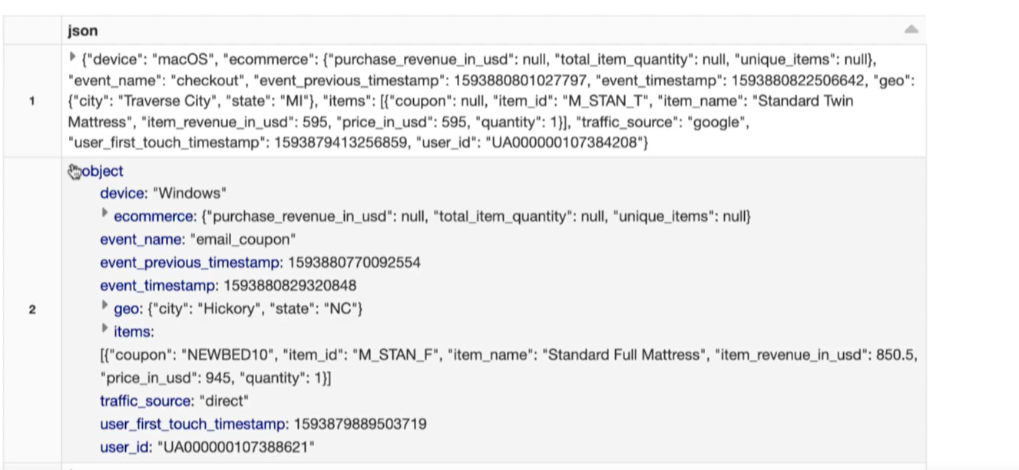

After using the from_json all the values in the value field is converted to struct_type

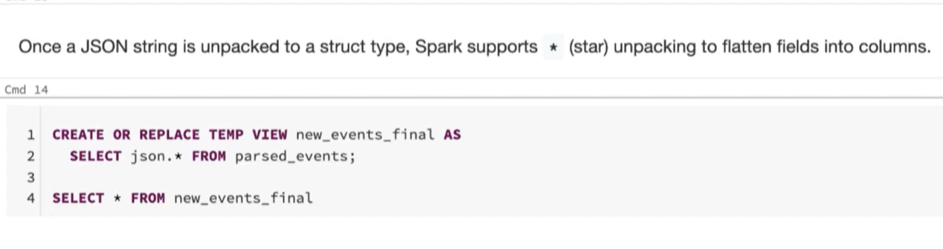

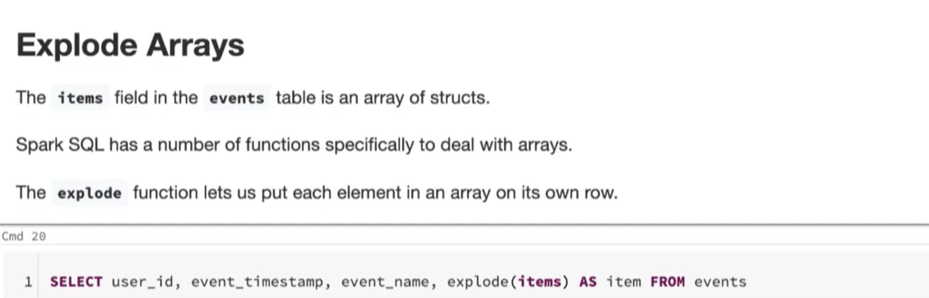

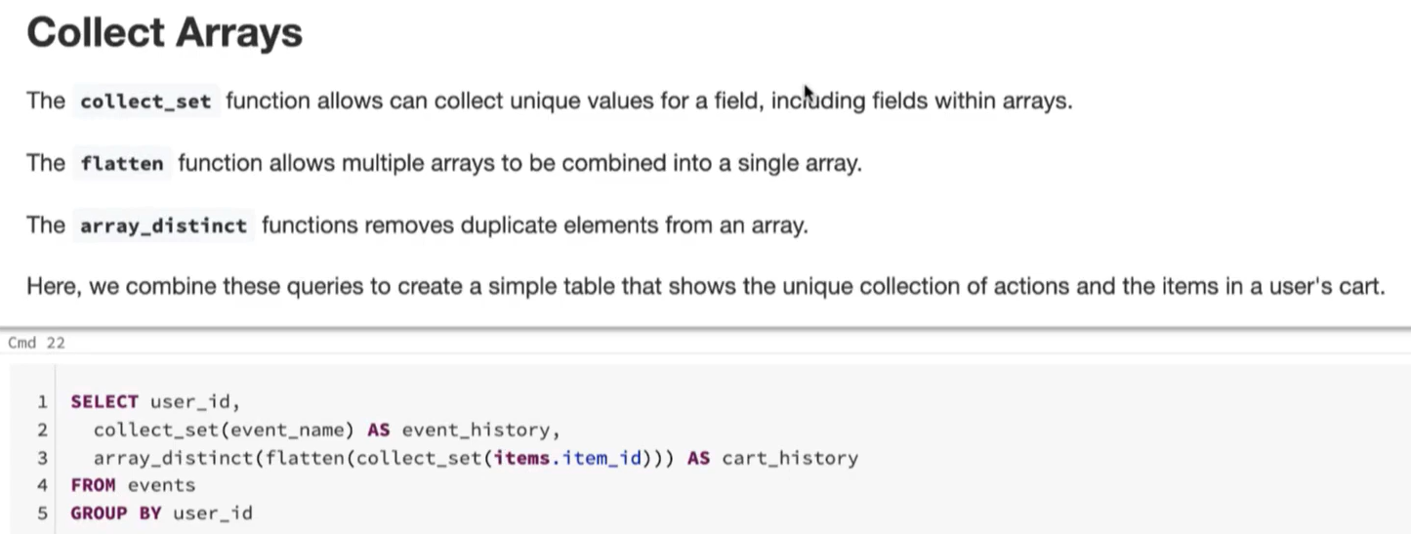

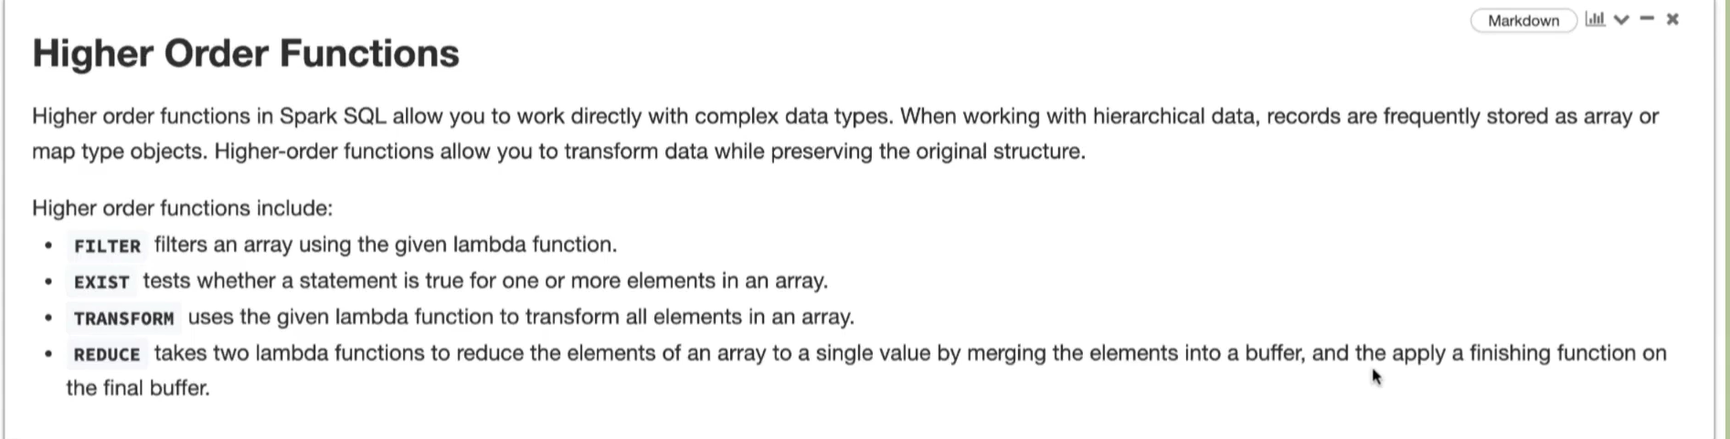

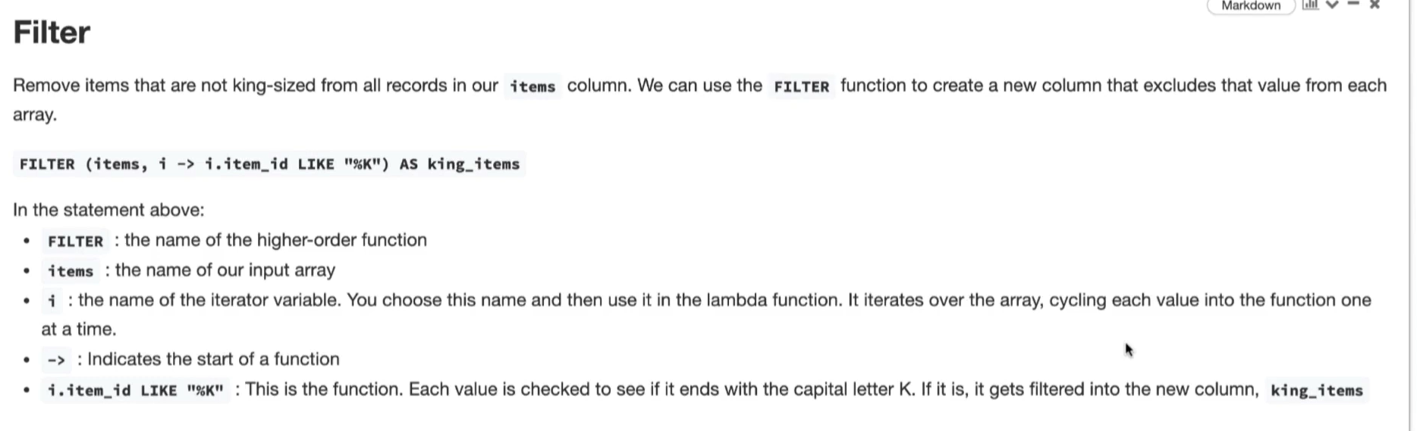

Eg –

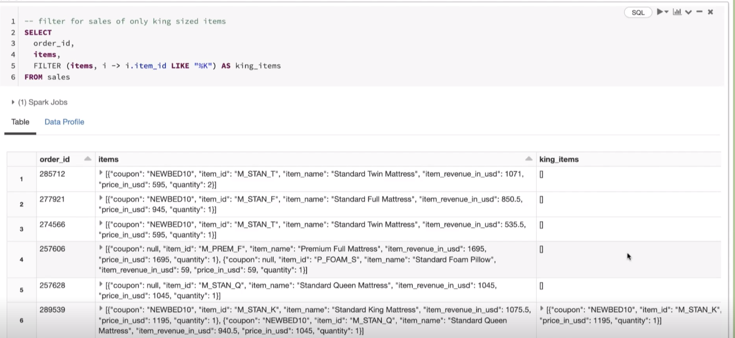

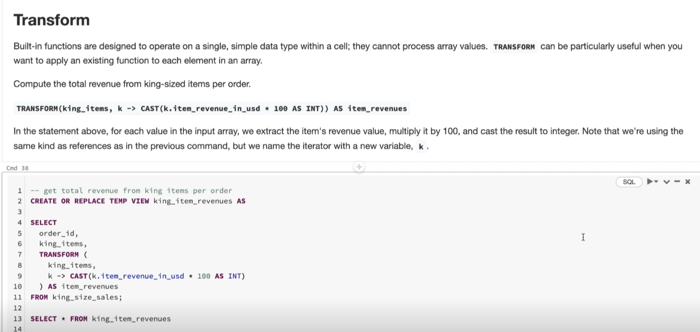

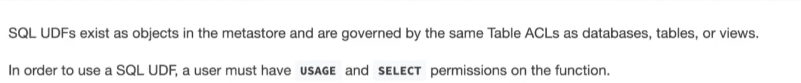

Auto loader is used for Incremental Data Ingestion

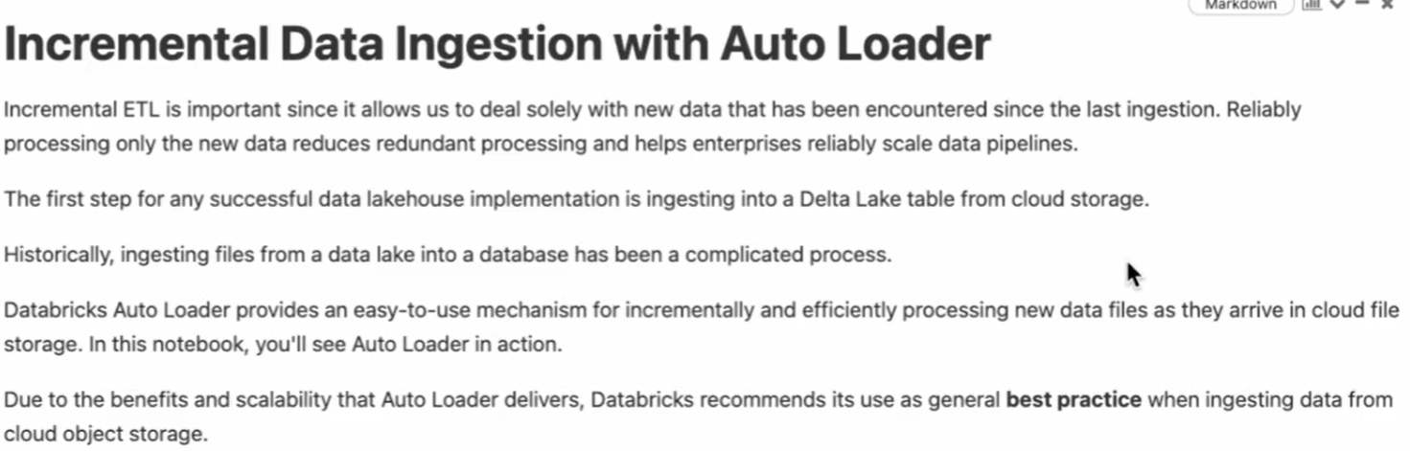

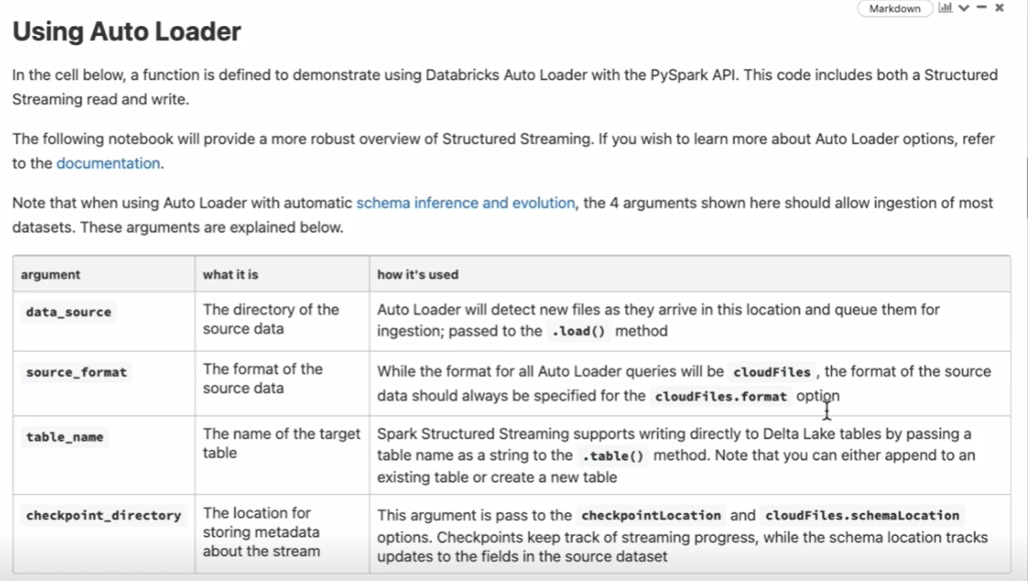

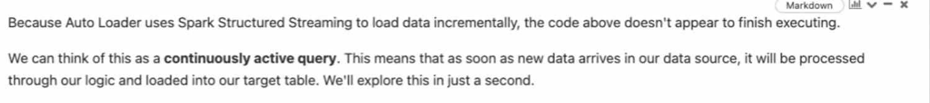

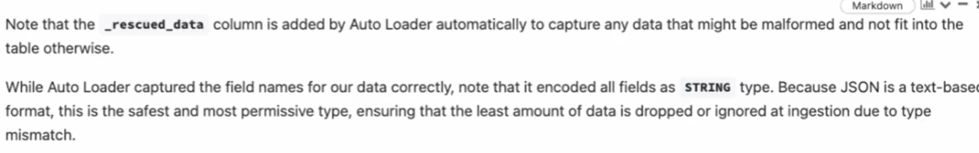

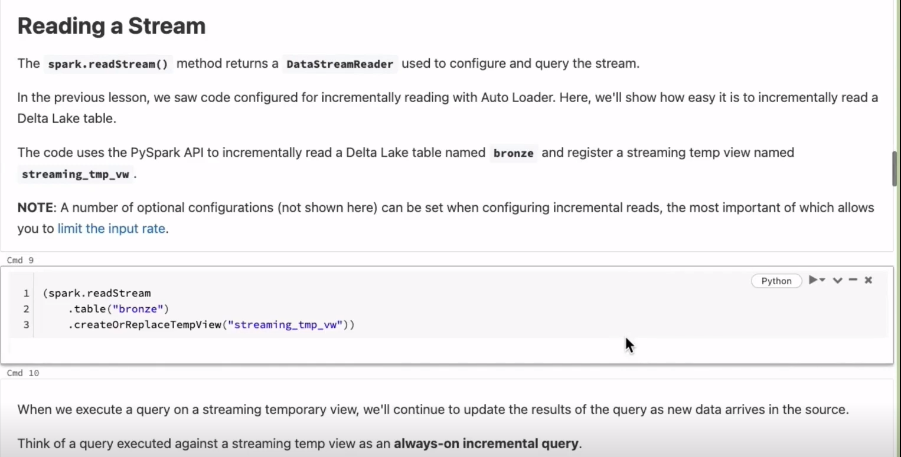

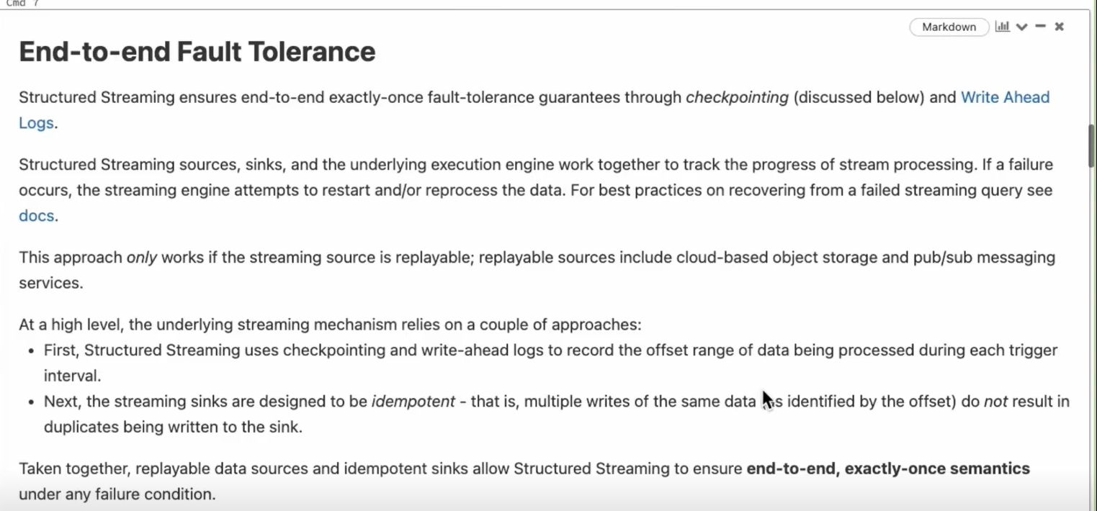

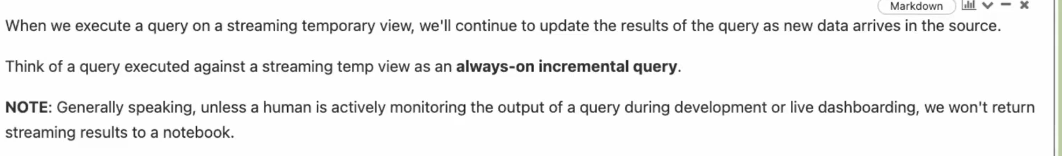

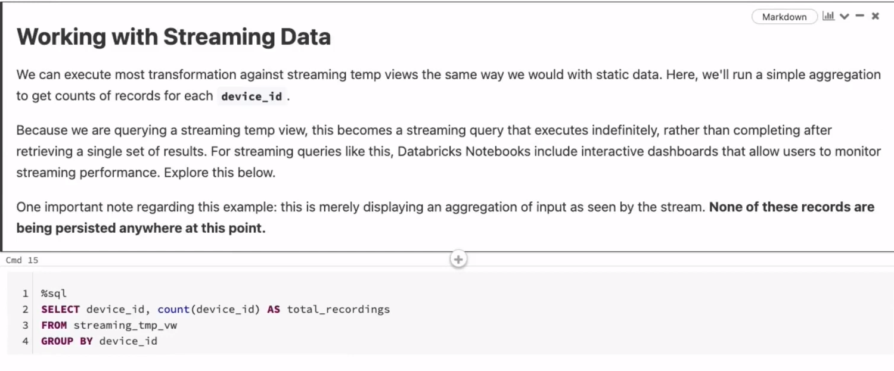

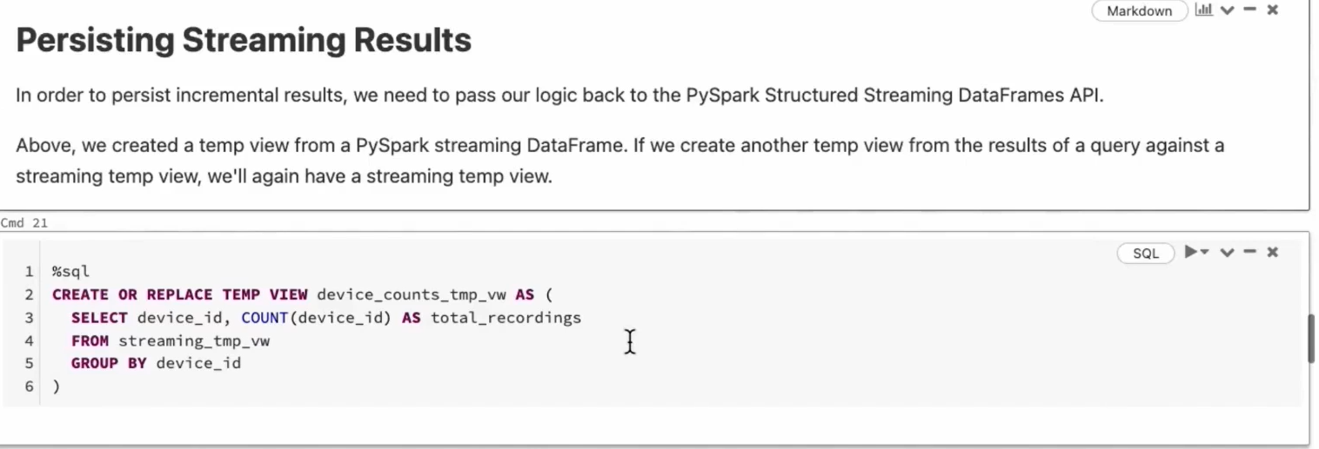

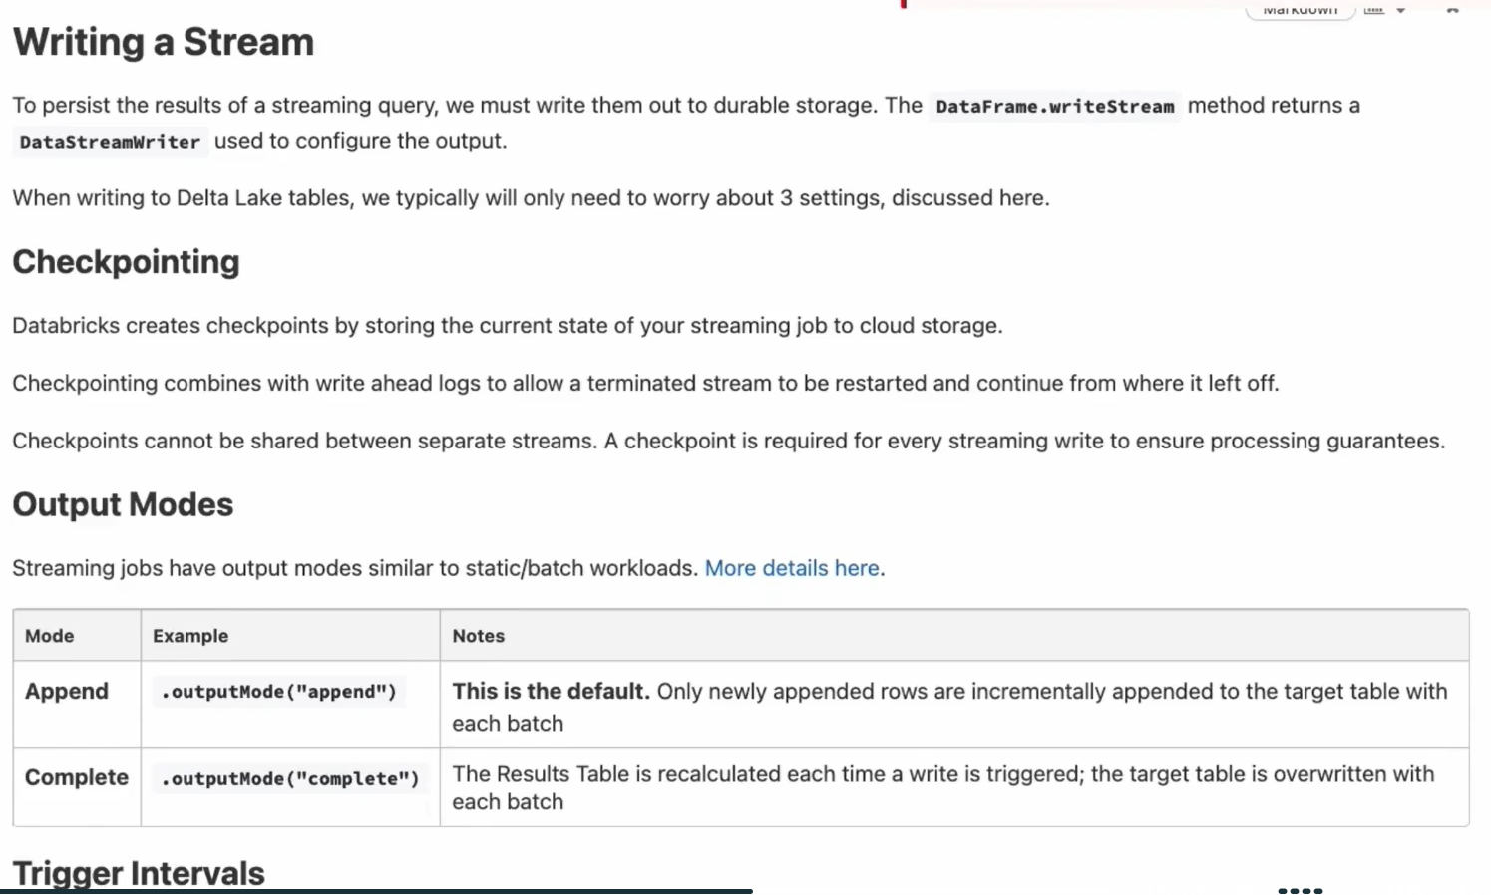

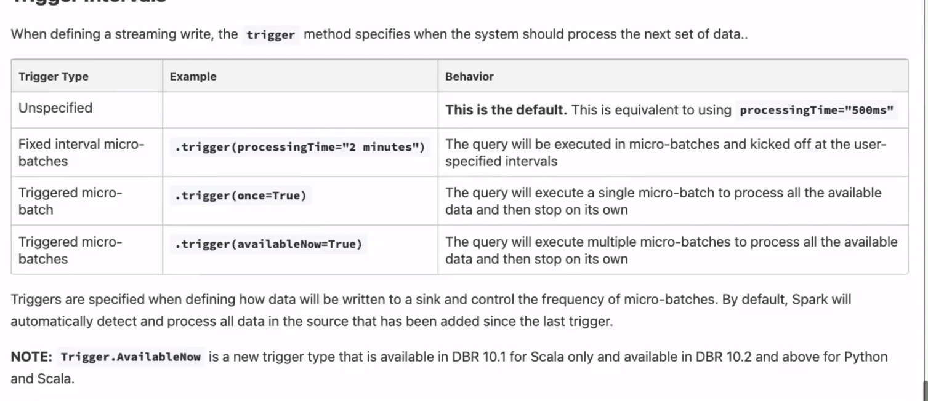

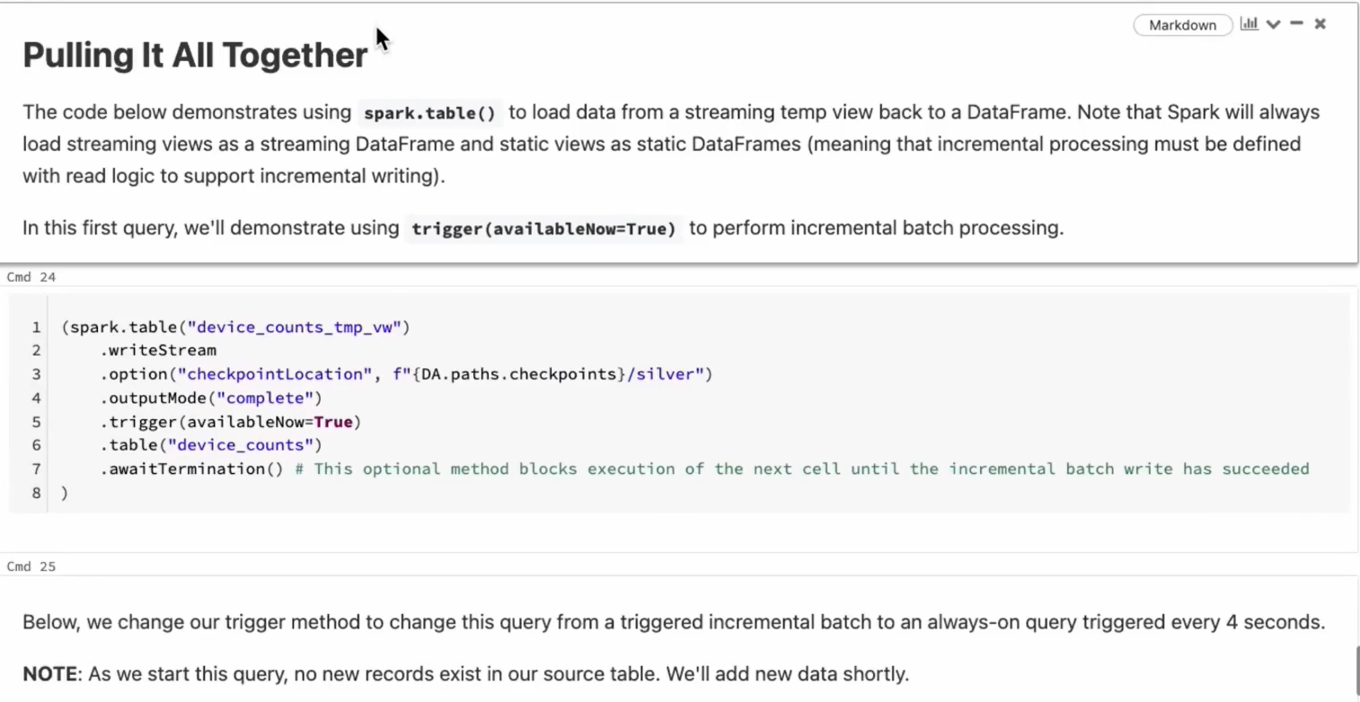

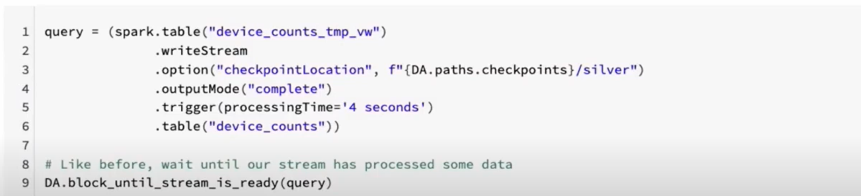

Imp Note the difference between 2 queries

a)  
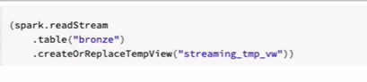

b) 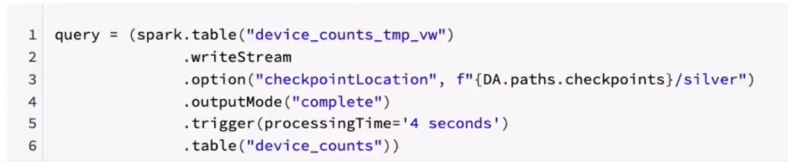

In a), Since there is a spark.readstream in read so the o/p will aslo be a streaming view meaning after executing select query on the sink (streaming_tmp_view), even though it has displayed the results of the query, the query will keep on executing and it will not stop since it is a streaming query

While in b) since there is a spark.table in read so in the o/p(select query on sink(device_counts) also once the query will display the result , the query is complete and it will stop.

Note – Whenever there is CloudFiles written it means we are using Auto-Loader else we are using Structured Streaming

Delta Live Tables – For Delta Live table Pipelines users are given the availability to choose between batch and streaming pipelines and also they can work with python and SQL both together.

